LINUX SYSTEM AND BASIC COMMAND

LINUX SYSTEM AND BASIC COMMAND

## **Display CPU information**

The lscpu utility provides a comprehensive summary of your CPU's capabilities, including model information, the number of cores, speeds, flags, virtualization capabilities, and security mitigations applied.

`

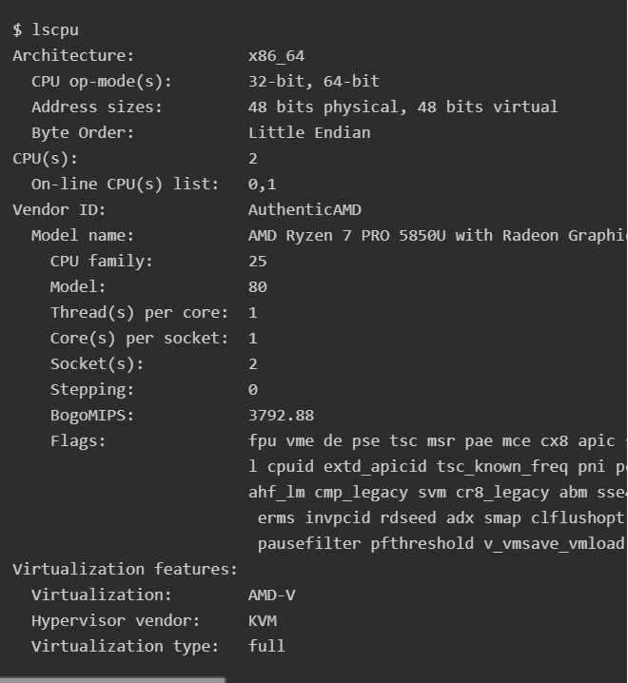

Gather disk information

## **Gather disk information**

Linux provides many utilities to look at the storage and disks attached to your system, such as df, fdisk, or mount. These are great options for gathering specific information. You can also use lsblk to get an overview of your block devices at a glance:

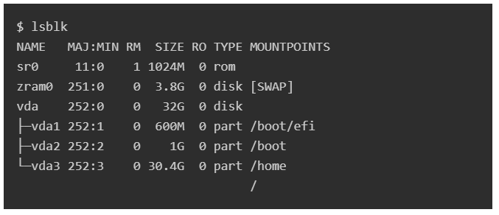

## 

## 

## 

## 

## 

## 

## [**Linux df command**](https://opensource.com/article/21/7/check-disk-space-linux-df)

The df command stands for "disk-free," and shows available and used disk space on the Linux system.

df -h shows disk space in human-readable format

df -a shows the file system's complete disk usage even if the Available field is 0

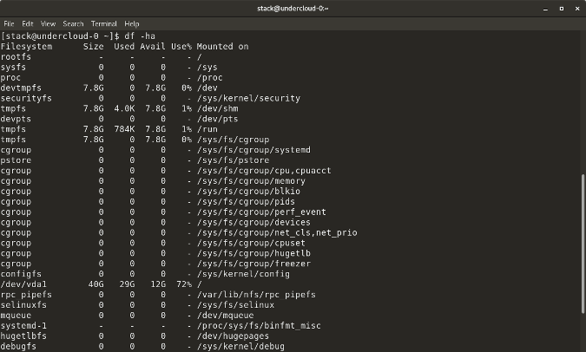

df -T shows the disk usage along with each block's filesystem type (e.g., xfs, ext2, ext3, btrfs, etc.)

df -i shows used and free inodes

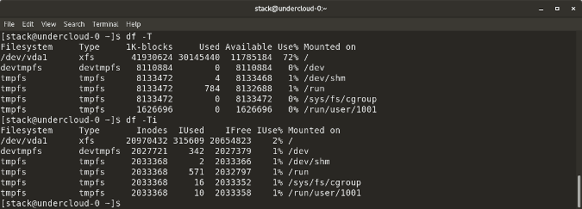

## [**Linux du command**](https://opensource.com/article/21/7/check-disk-space-linux-du)

du shows the disk usage of files, folders, etc. in the default kilobyte size

du -h shows disk usage in human-readable format for all directories and subdirectories

du -a shows disk usage for all files

du -s provides total disk space used by a particular file or directory

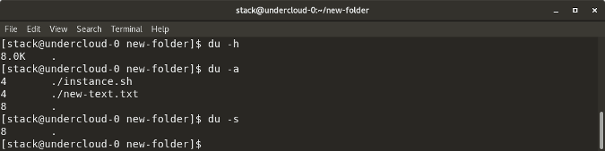

## **Linux fdisk -l command**

fdisk -l shows disk size along with disk partitioning information

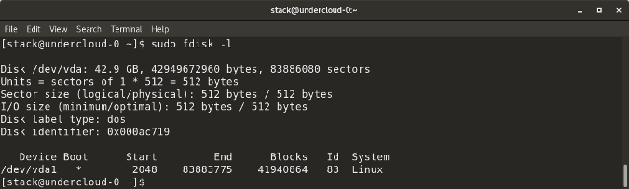

Show USB information

## **Show USB information**

Use the lsusb utility to gather information about available USB devices. Your distribution may not include this utility by default. Install the usbutils package to access it:

$ sudo dnf install -y usbutils

Then use lsusb to see a list of USB devices

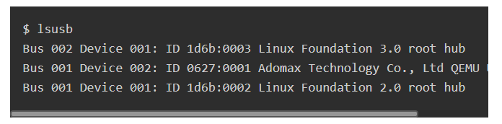

Display PCI information

## **Display PCI information**

Next on the list is lspci to get information about your PCI devices. This utility is part of the pciutils package, and you may need to install it, depending on your distribution:

sudo dnf install -y pciutils

Run lspci for a summary of all attached PCI devices:

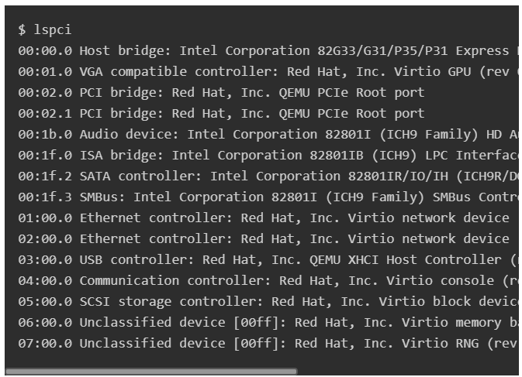

You can use the -v option for a more detailed output, -k to list the Linux kernel module in use by the device, and -s to filter specific devices based on their ID. For example, to list kernel modules for device 05:00.0, use:

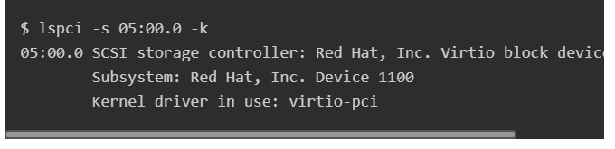

Show RAM information

## **Show RAM information**

For basic RAM utilization information, use the command free:

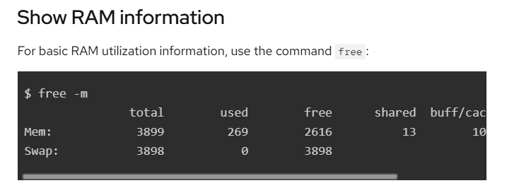

For additional information about your RAM hardware, including the number and type of slots available, manufacturing information, sizes, and other physical details, use the dmidecode utility. This generic utility provides information about many hardware and firmware components. You can install it with the dmidecode package

$ sudo dnf install -y dmidecode

Since dmidecode provides a huge dump of information, you can filter its output using the option -t TYPE to list specific types only. For example, to display only RAM-related information, use -t memory:

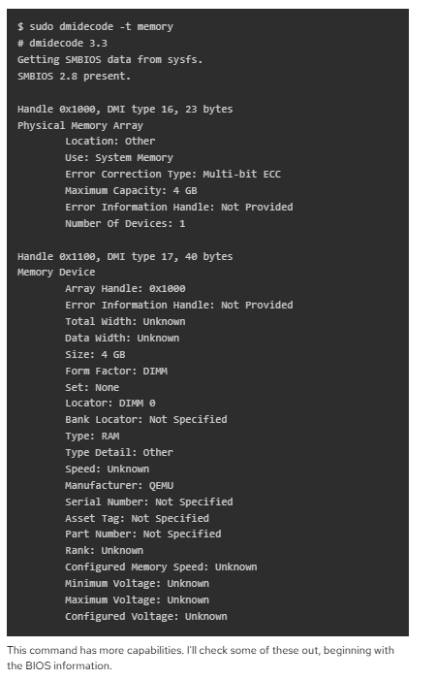

Display BIOS information

## **Display BIOS information**

Use dmidecode -t bios to see a summary of your BIOS information:

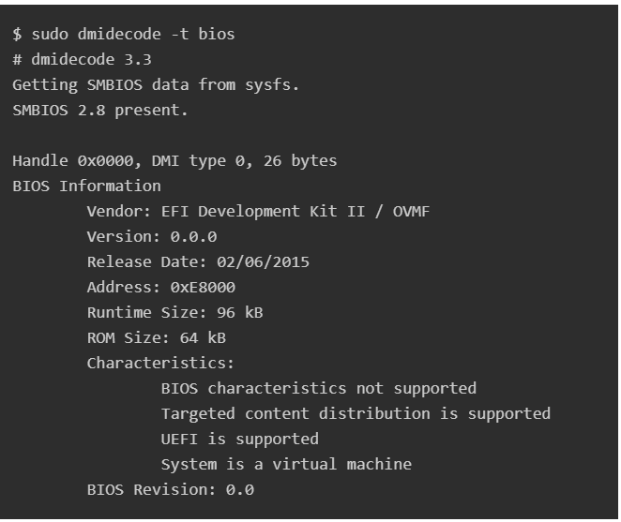

Show system information

## **Show system information**

Finally, for general hardware information, including manufacturing and product serial numbers, use dmidecode -t system:

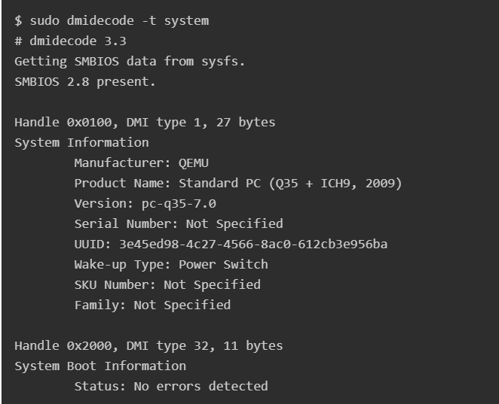

This information is useful for finding online documentation about your hardware or obtaining vendor support.

## 

## 

## **What's next?**

I've listed some command-line utilities that help you to understand the system and hardware where you run your Linux operating system. Some of these utilities are specialized, while dmidecode is generic. You can see all information that it can provide by using dmidecode -t:

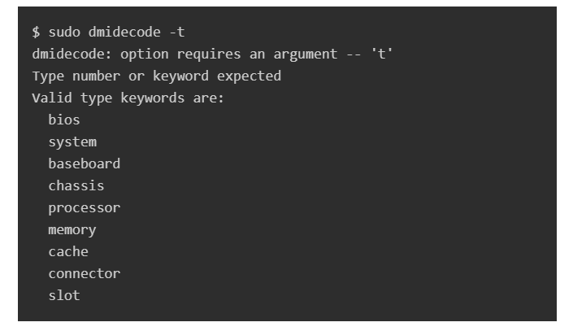

Other high-level utilities provide detailed information about hardware like hwinfo or GUI tools such as cpu-x

How to Check Current OS Version in Linux

How to Check Current OS Version in Linux

OS version in Linux, open the command line and use one of the commands like “cat /etc/os-release”, “lsb_release -a”, “hostnamectl”, or “uname -r”

You can also check the Linux OS by using the /etc/os-release file. This file is located in the /etc directory, which contains the core configuration files of the system.

cat /etc/os-release

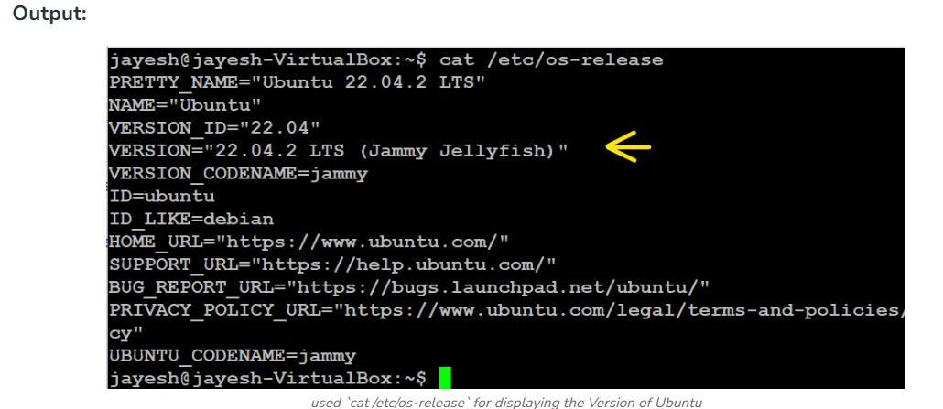

grep '^VERSION' /etc/os-release

grep -E '^(VERSION|NAME)=' /etc/os-release

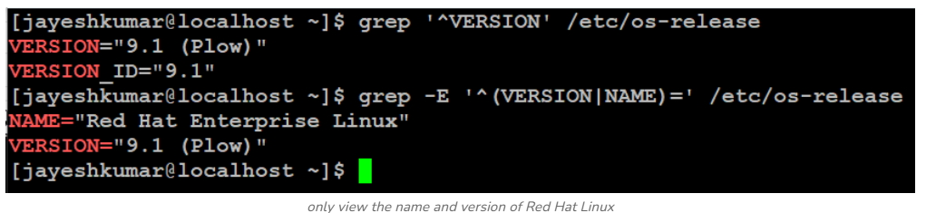

lsb_release -a

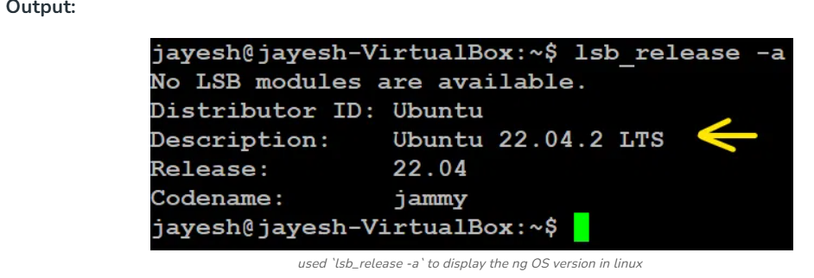

hostnamectl

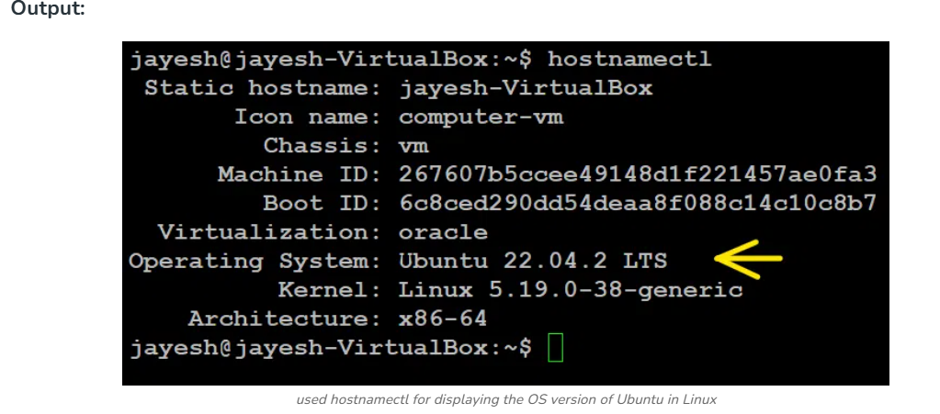

uname -r

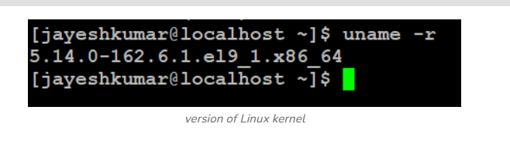

SYSTEM UPTIME

# How to check uptime for a Linux Server

## 1) Check uptime for a server using the uptime command

Let’s begin with the simple uptime command.

$ uptime

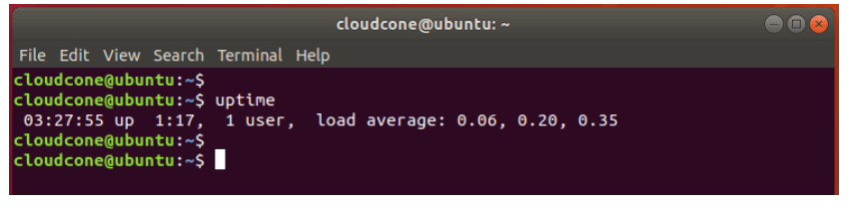

$ uptime -s

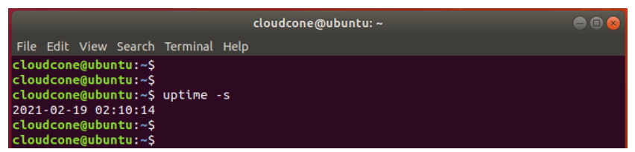

uptime -p

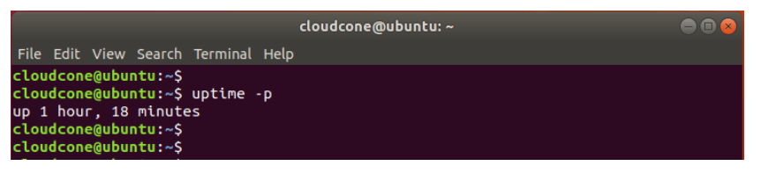

## Check uptime using the w command

$ w

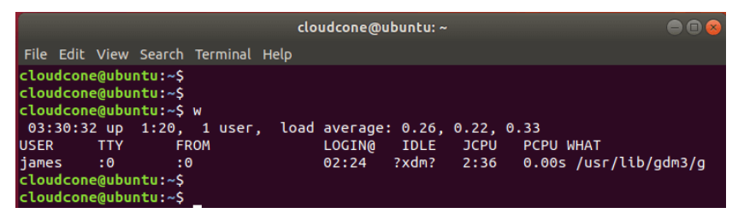

## 

## 

## 

## 

## 3) Check uptime for a Linux server using neofetch utility

$ neofetch

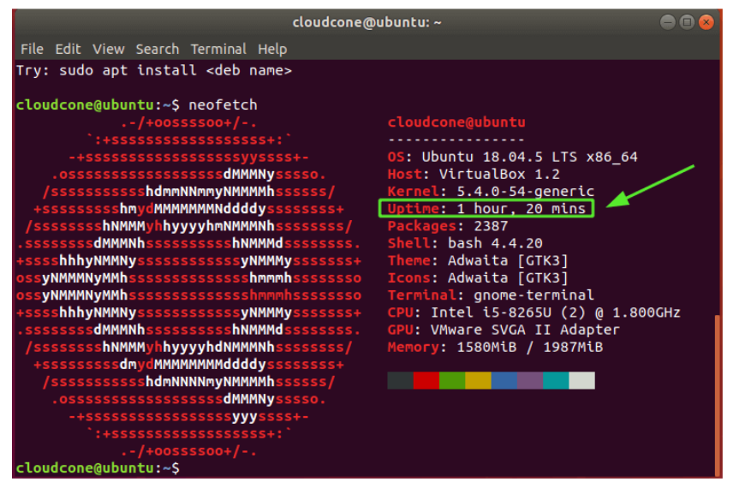

## 

## 

## 

## 

## 

## 4) Check uptime using top / htop utilities

The Linux top command is used to check currently running processes on a system. However, you can retrieve other information from the top section of the output such as load average, memory size, CPU utilization, and uptime.

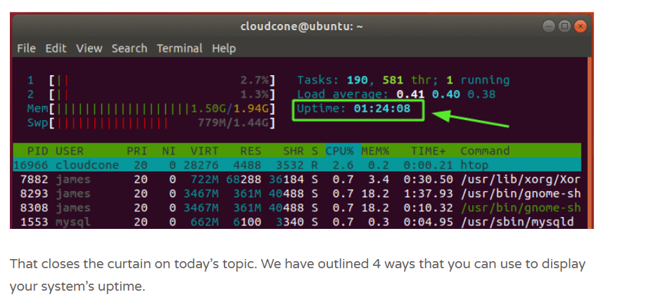

Utilization

# **Linux commands to check CPU Utilization ,memory and disk.**

# **CPU utilization**

# To check CPU utilization in linux we have different commands. Lets check..

# **1. Top** It provides real-time information about **system performance, including CPU and memory utilization**.

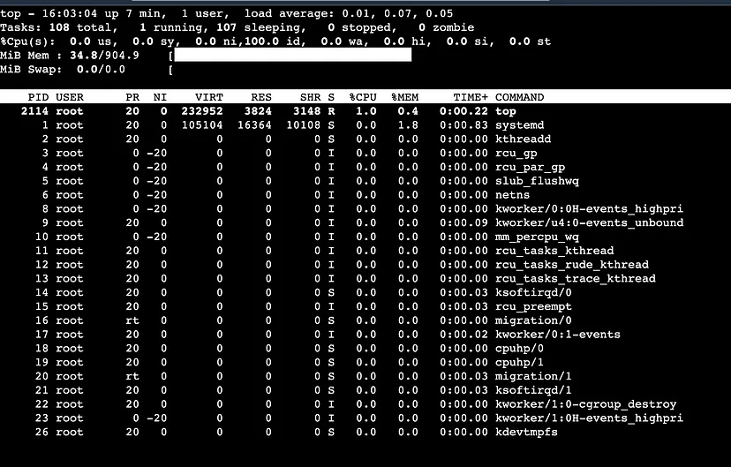

By default, top command updates the data every 5 seconds.

It has different option to sort process like —

**P** to sort all running processes by **CPU** **usage**.

**M** to sort all running processes by **Memory** **usage**.

**I** to hide all **idle** processes

**S** to sort all processes by how long the processes have been running.

**U** to view all processes owned by a specific user.

## **2. mpstat**

This command displays **CPU usage statistics.** You can specify the interval and number of iterations to monitor CPU usage over time.To use this first we have to check sysstat package.

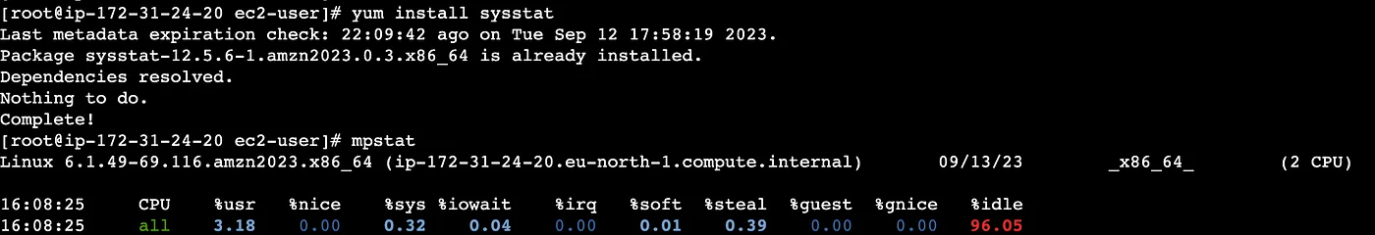

To display the report of all processors

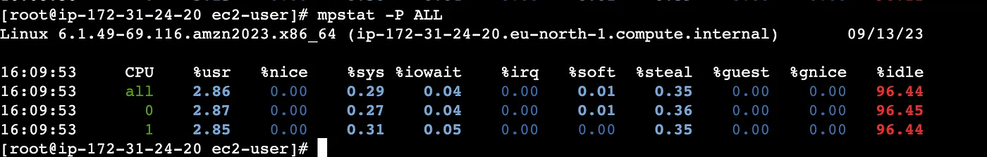

## 

## 

## 

## **3. sar**

This command collects, reports, and saves system activity information, including CPU and memory usage.with **-u** option to track CPU performance followed by time in sec

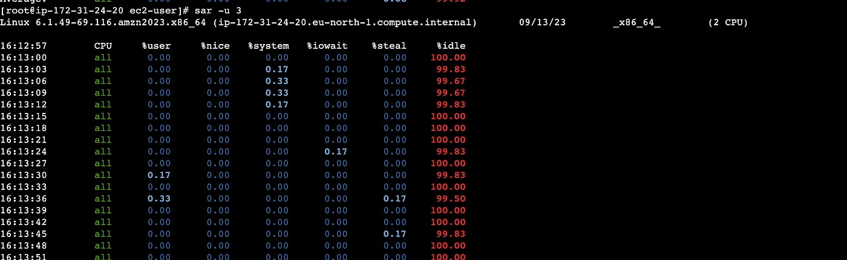

## **iostat**

This command in Linux is used to report and monitor system input/output (I/O) device statistics, including information about disk utilization and performance.

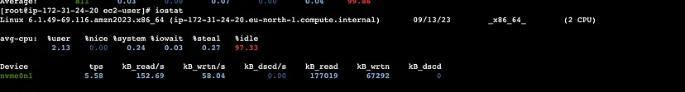

**Use the -c option to break the CPU utilization into user processes, system processes, I/O wait, and idle time.**

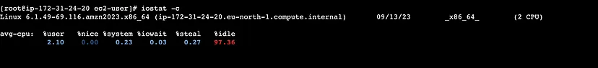

## 

## 

## 

## 

## 

## 

## 

## 

## 

## **5. vmstat**

This command in Linux is used to display information about system virtual memory usage, as well as **other system statistics such as CPU usage**, disk I/O, and system processes.

This command in Linux is used to display information about system virtual memory usage, as well as **other system statistics such as CPU usage**, disk I/O, and system processes.

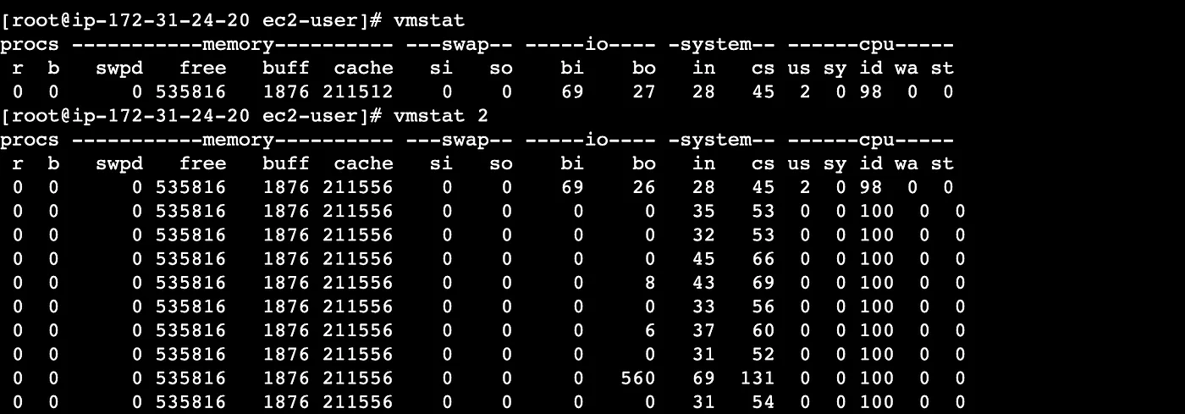

# **Memory and disk utilization**

To check Memory in linux we have different commands. Lets check..

## **1. free**

This command **displays memory and swap space utilization i**n kilobytes or megabyte

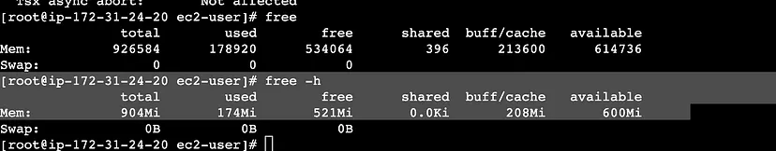

## **2. df**

This command is used to **display information about disk space usage on mounted filesystems.**

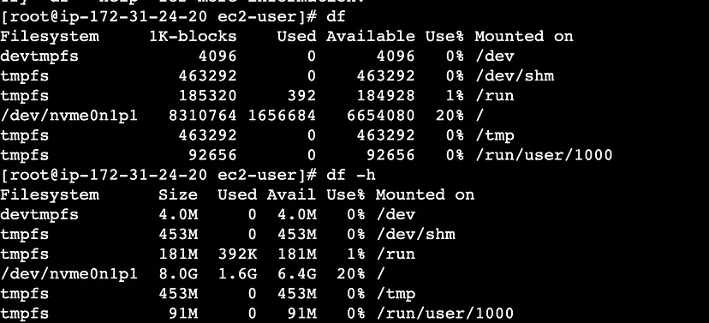

## **3. du**

**This command is used to estimate file and directory space usage.**

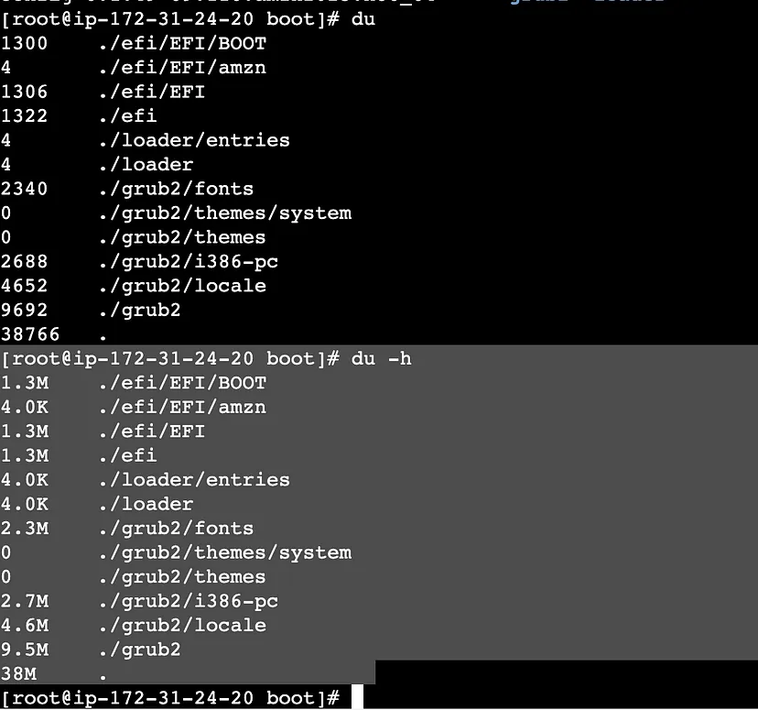

**To get largest file or folder using sort “du -s * | sort -n” .**

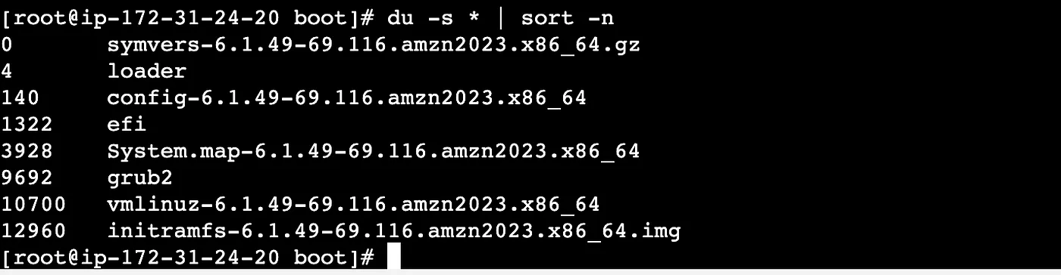

Logged-In Users

# **How to List Current Logged-In Users in Linux**

* [1. Using who Command to List Current Logged-in Users in Linux](https://www.geeksforgeeks.org/who-command-in-linux/#1-using-who-command-to-list-current-loggedin-users-in-linux)
* [2. Using user Command to List Current Logged-in Users in Linux](https://www.geeksforgeeks.org/who-command-in-linux/#2-using-user-command-to-list-current-loggedin-users-in-linux)
* [3. Using w Command to List Current Logged-in Users in Linux](https://www.geeksforgeeks.org/who-command-in-linux/#3-using-w-command-to-list-current-loggedin-users-in-linux)
* [4. Using last Command to List Current Logged-in Users in Linux](https://www.geeksforgeeks.org/who-command-in-linux/#4-using-last-command-to-list-current-loggedin-users-in-linux)
* [5. Using `finger` Command to List Current Logged-in Users in Linux](https://www.geeksforgeeks.org/who-command-in-linux/#5-using-finger-command-to-list-current-loggedin-users-in-linux)
* [6. Using top Command to List Current Logged-in Users in Linux](https://www.geeksforgeeks.org/who-command-in-linux/#6-using-top-command-to-list-current-loggedin-users-in-linux)

## **1. Using who Command to List Current Logged-in Users in Linux**

The who command is a simple and effective way to display information about currently logged-in users. By typing who in the terminal, you will receive a list of usernames, terminal IDs, login times, and originating IP addresses if applicable.

**who** command is used to find out the following information :

1. Time of last system boot
2. Current run level of the system
3. List of logged-in users and more.

### **Syntax of who Command**

who [options] [filename]

### **Practical Examples of who Command**

1. The who command displays the following information for each user currently logged in to the system if no option is provided :

* Login name of the users
* Terminal line numbers
* Login time of the users into the system
* The remote host name of the user

hduser@mahesh-Inspiron-3543:~$ who

hduser tty7 2018-03-18 19:08 (:0)

. To display host name and user associated with standard input such as keyboard

hduser@mahesh-Inspiron-3543:~$ who -m -H

NAME LINE TIME COMMENT

3. To show all active processes which are spawned by INIT process

hduser@mahesh-Inspiron-3543:~$ who -p -H

NAME LINE TIME PID COMMENT

4. To show status of the users message as +, – or ?

hduser@mahesh-Inspiron-3543:~$ who -T -H

NAME LINE TIME COMMENT

hduser + tty7 2018-03-18 19:08 (:0)

5. To show list of users logged in to system

hduser@mahesh-Inspiron-3543:~$ who -u

hduser tty7 2018-03-18 19:08 01:16 3357 (:0)

6. To show time of the system when it booted last time

hduser@mahesh-Inspiron-3543:~$ who -b -H

NAME LINE TIME PID COMMENT

system boot 2018-03-18 19:07

7. To show details of all dead processes

hduser@mahesh-Inspiron-3543:~$ who -d -H (NO dead process in this case)

NAME LINE TIME IDLE PID COMMENT EXIT

NAME LINE TIME IDLE PID COMMENT EXIT

8. To show system login process details

hduser@mahesh-Inspiron-3543:~$ who -l -H

NAME LINE TIME IDLE PID COMMENT

LOGIN tty1 2018-03-18 19:07 3073 id=tty1

9. To count number of users logged on to system

hduser@mahesh-Inspiron-3543:~$ who -q -H

hduser

# users=1

10. To display current run level of the system

hduser@mahesh-Inspiron-3543:~$ who -r

run-level 5 2018-03-18 19:07

11. To display all details of current logged in user

hduser@mahesh-Inspiron-3543:~$ who -a

system boot 2018-03-18 19:07

LOGIN tty1 2018-03-18 19:07 3073 id=tty1

run-level 5 2018-03-18 19:07

hduser + tty7 2018-03-18 19:08 01:13 3357 (:0)

12. To display system’s username

hduser@mahesh-Inspiron-3543:~$ whoami

hduser

13. To display list of users and their activities

hduser@mahesh-Inspiron-3543:~$ w

20:39:20 up 1:32, 1 user, load average: 0.09, 0.06, 0.07

USER TTY FROM LOGIN@ IDLE JCPU PCPU WHAT

hduser tty7 :0 19:08 1:32m 38.95s 0.19s /sbin/upstart -

14. To display user identification information

hduser@mahesh-Inspiron-3543:~$ id

uid=1001(hduser) gid=1001(hadoop) groups=1001(hadoop), 27(sudo)

## **2. Using user Command to List Current Logged-in Users in Linux**

The user command is a versatile tool for managing user accounts, and it also provides information about logged-in users. You can list the currently logged-in users .

users

## **3. Using w Command to List Current Logged-in Users in Linux**

The [`**w`** command](https://www.geeksforgeeks.org/w-command-in-linux-with-examples/) provides a wealth of information about currently logged-in users, including their usernames, terminal IDs, remote IP addresses, login times, CPU usage, and more. Running `**w`** without any options will display a comprehensive list of users and their activities.

w

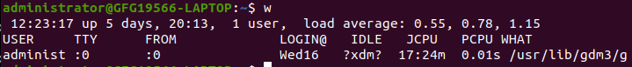

## **4. Using last Command to List Current Logged-in Users in Linux**

The[**`last`** command](https://www.geeksforgeeks.org/last-command-in-linux-with-examples/) shows a list of recently logged-in users, along with the times they logged in and out. By running `**last`** without any options, you can see a historical log of user logins.

last

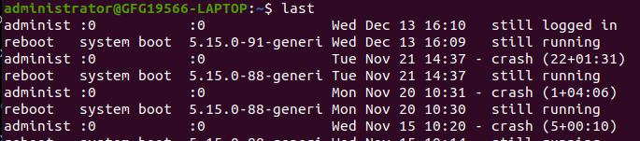

## **5. Using `finger` Command to List Current Logged-in Users in Linux**

The [`**finger`** command](https://www.geeksforgeeks.org/finger-command-in-linux-with-examples/) provides detailed information about a particular user or all users currently logged in. To list all logged-in users, simply type `**finger`** without any arguments. For information on a specific user, use `**finger <username>`**

finger

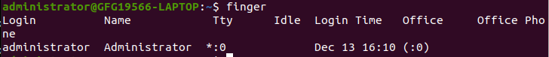

## **6. Using top Command to List Current Logged-in Users in Linux**

While primarily known for displaying real-time system statistics, the `**top`** command also lists the currently logged-in users. To view the user list, run `**top`** and then press `**u`**. This will show a list of logged-in users and their associated processes.

top

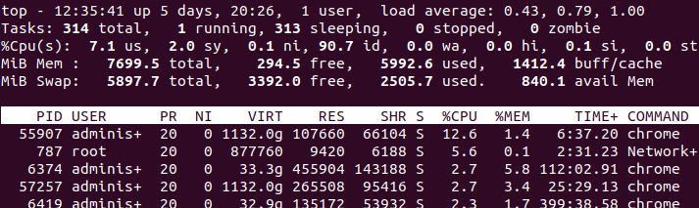

Running a command

echo "Running a command..." ls /nonexistent_directory echo "Exit status: $?" In this example, ls /nonexistent_directory will fail, and echo "$?" will display the exit status of the last command, indicating success (0) or failure (non-zero)

echo $?

[root@localhost ~]# lsalth

bash: lsalth: command not found...

Failed to search for file: /run/media/root/RHEL-9-2-0-BaseOS-x86_64/AppStream was not found

[root@localhost ~]# echo $?

127

[root@localhost ~]#